METHILHAVEN SURGERY

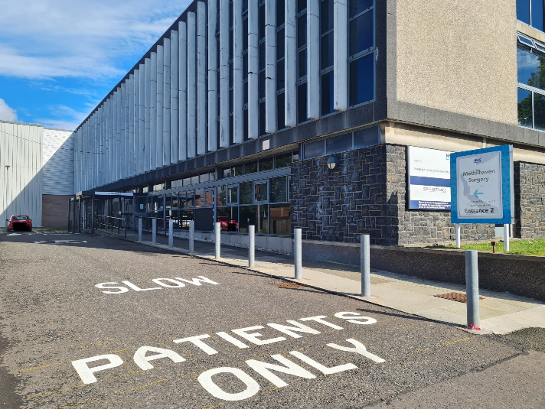
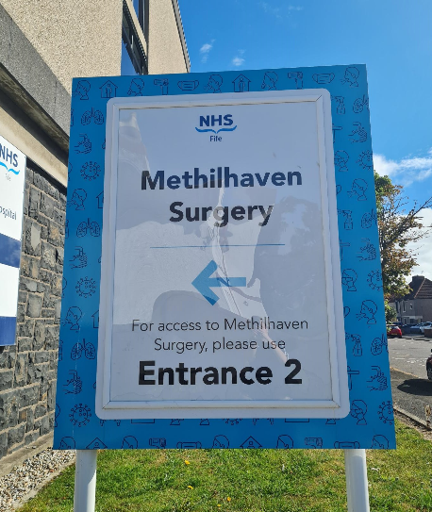

August 2022 Newsletter

New Premises – Wellesley Unit, Randolph Wemyss Memorial Hospital

Monday 1st August will see us open within the Wellesley Unit at Randolph Wemyss Memorial Hospital. Please note that we will be running an emergency surgery on the Thursday 28th July through to Tuesday 2nd August while we move and settle in to the new premises. The contact number remains the same - 01333 426913. We appreciate your patience during this difficult period of transition.

Please see attached letter, which was sent to patients by NHS Fife

H:\RWMH + Airlie information\Methilhaven Letter to patients July 2022 - final.docx

Contact details – remain the same 01333 426913

Prescription requests – via the practice website or your usual chemist.

Appointments

At the moment these are released on the day booking from 8.30am each day by phone call only. All requests for appointments will be triaged by a clinician to ensure you are directed to the appropriate member of the multi-disciplinary team.

Practice Nurse and Phlebotomy (bloods) can be booked via reception as normal.

NHS Fife are working to provide clinical cover in for the form of GPs, Advanced Nurse Practitioner (ANP) and Advanced Paramedic Practitioners (APP). However, our multi-disciplinary team which include First Contact Physio, Mental Health Triage Nurse and Pharmacy Team will be moving with us with no changes.

SURGERY CLOSURES & PUBLIC HOLIDAYS

No planned closures at present.

Prescriptions
You must allow at least 72 hours for us to prepare your prescriptions.

Please take responsibility for your own medications, ensuring you do not run out as we are unable to print emergency/urgent prescriptions.

You can order your prescription a number of ways:
- Handing your request in the your pharmacy
- Visiting our website at www.methilhavensurgery.co.uk

Please note that we do not take prescriptions over the telephone.
Take note of our closing dates and hand your request in with plenty of time.

Mental Health Triage Nurse

We have a Mental Health Triage Nurse starting with the practice. They will be working one day per week on a Friday. Online Consult forms should be submitted and the clinical team will sign post you to this service. The nurse will be dealing with various including, low mood, anxiety, depression, insomnia, stress, relationship difficulties trauma etc.

Maternity Services

The way in which midwife appointments are booked has changed. Please take a look at the following link :
https://www.nhsfife.org/services/all-services/maternity/youre-pregnant-what-happens-now/

Prefer to make a telephone booking?
Call: 01592 643355 ext 28374
Monday-Friday, 10.00am to 12.00noon

Podiatry Self referral

Please follow the below link if you require referral to Podiatry.
https://www.nhsfife.org/services/all-services/podiatry-foot-health/request-for-assistance/

Travel Vaccinations
The NHS FifeFitforTravel (FFT) webpage https://www.nhsfife.org/services/all-services/travel-vaccination-for-going-abroad/ will be live from 01 April 2022, details and contact telephone numbers for local pharmacies providing travel health service are available on the FFT webpage which is linked to NHS Inform and PHS or for more information, including opening hours, visit https://www.nhsinform.scot/pharmacies.

Where a user is unable to access and/or navigate FFT, NHS24 will provide a telephone-based access point for NHS Fife's local service delivery, telephone: 0800 22 44 88

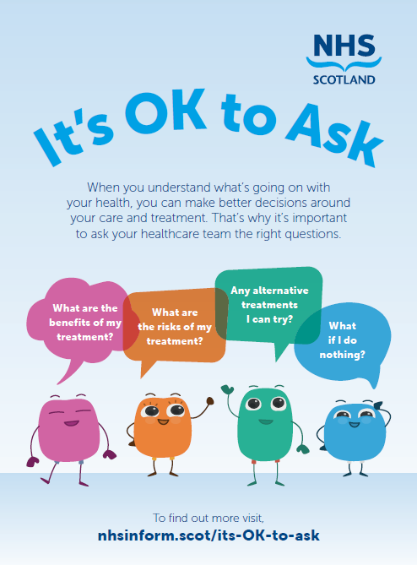

Sam’s was established in 2019, initially based in Kirkcaldy.
Sam’s is now available in:
Kirkcaldy (Monday and Friday)
Dunfermline (Thursday and Sunday)
Leven (Tuesday, Wednesday and Saturday)
Burntisland (Thursday)
(all 12 noon – 8pm)

https://www.samscafe.org.uk/Index.asp?MainID=29424

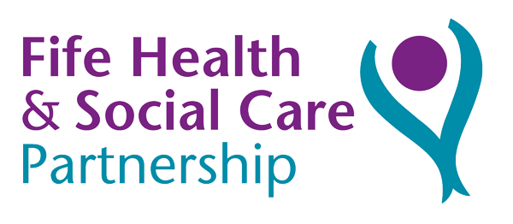

USEFUL LINKS

Press Ctrl and click on item below to go to links

http://www.bma.org.uk/YourGPcares http://www.tinnitus.org.uk
www.cancerresearchuk.org www.selfhelp4stroke.org
www.macmillan.org.uk www.samh.org.uk
www.asthma.org.uk www.mylungsmylife.org
www.dapl.net www.fifecarerscentre.org
www.bowelscreening.scot.nhs.uk www.stampoutgout.co.uk
www.mydiabetesmyway.scot.nhs.uk www.moodcafe.co.uk
www.accesstherapiesfife.scot.nhs.uk

